(A12E) – Home Schooled Counts Form

Instructions:
Please report the number of notifications received from families establishing a home education program from October 2, 2022 through October 1, 2023. Districts should not include students who participated in a home education program and were reported in the prior year.

Home Schooled Counts
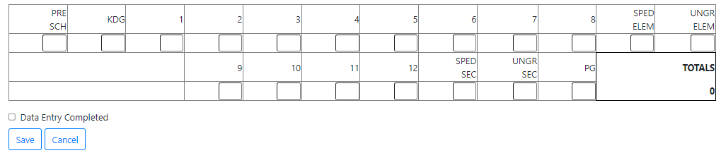

Category | Description
PRESCH – Preschool | Total number of preschool students.
KDG – Kindergarten | Total number of kindergarten students.
1-8 - Grade Level | Total number of students per grade level - do not include SPED students in grade level totals.
SPED ELEM - Special Education Elementary | Total number of SPED elementary students.
UNGR ELEM - Ungraded Elementary | Total number of elementary students who do not fall into a grade level category.
9-12 - Grade Level | Total number of students per grade level - do not include SPED students in grade level total.
SPED SEC - Special Education Secondary | Total number of SPED secondary students.
UNGR SEC - Ungraded Secondary | Total number of secondary homeschool students who do not fall into a grade level category.
PG - Post Grad | Total number of post grad students.
TOTALS | The sum of all categories.

