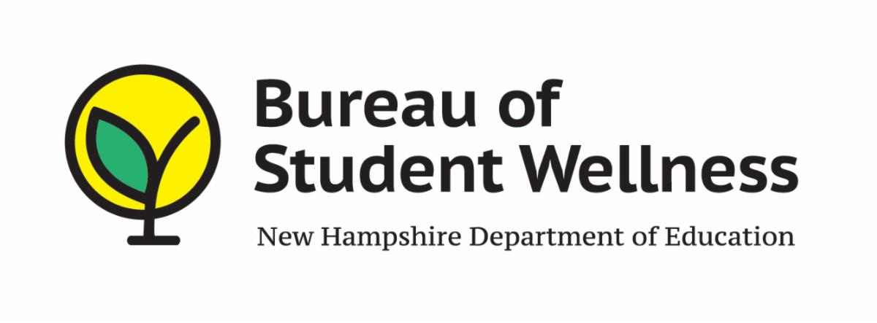
OFFICE OF NUTRITION PROGRAMS AND SERVICES
101 PLEASANT STREET
CONCORD, NH 03301

SY 2021-2022 WAIVER REQUEST FORM FOR
WAIVER # 89

PARENT/GUARDIAN PICK-UP OF SCHOOL MEALS

Name of SAU: Click or tap here to enter text.

SAU / RA number: Click or tap here to enter text.

List of schools participating in the waiver: Click or tap here to enter text.

WAIVER JUSTIFICATION: Click or tap here to enter text.

PLEASE NOTE: A SAU/RA written plan must be in place for ensuring meals are distributed only to parents/guardians of eligible children and how duplicate meals will not be distributed. This plan will be reviewed during the Administrative Review.

_______________________ Date: Click or tap to enter a date.
Superintendent’s Signature

Print Name: Click or tap here to enter text.

*Please use this form for only waiver #89

Email pdf Format To: marty.b.davis@doe.nh.gov

