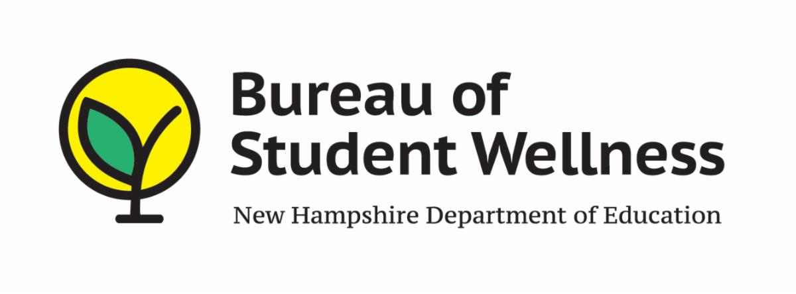
OFFICE OF NUTRITION PROGRAMS AND SERVICES
101 PLEASANT STREET
CONCORD, NH 03301

SY 2021-2022 WAIVER REQUEST FORM FOR
WAIVER # 90

MEAL PATTERN FLEXIBILITY FOR NSLP/SBP/SSO

NAME OF SAU / ORGANIZATION: Click or tap here to enter text.

SAU / RA NUMBER: Click or tap here to enter text.

LIST OF SCHOOLS PARTICIPATING IN THE WAIVER: Click or tap here to enter text.

PLEASE NOTE: This waiver request may target the flexibilities for the following list of nutrients/ food components. Please check off the items below that apply to your food service operation that need the flexibility. You must provide justification for each flexibility checked off.

☐ Menus need not meet the dietary specification for SODIUM
☐ All GRAINS offered need not be whole grain rich
☐ Preschoolers need not to have at least 1 serving/day for all meals to be whole
GRAIN rich
☐ Need not offer a variety of MILK (at least 2 different kinds)
☐ Menus and food components do not have to meet age/grade group requirements

WAIVER JUSTIFICATION: Click or tap here to enter text.

______________________ Date: Click or tap to enter a date.
Superintendent’s Signature

Print Name: Click or tap here to enter text.

*Please Use One Form, Per Waiver Request

Email pdf Format To: marty.b.davis@doe.nh.gov

