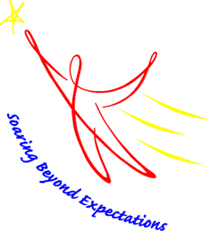

Nita M. Lowey 21st Century Community Learning Center (21st CCLC)
USED Program Income Questionnaire

Per The United States Department of Education (USED), beginning 2023-2024, State Education Agencies (SEA’s) in accordance with Uniform Guidance §200.307, are required to submit a request seeking prior approval for each subgrantee that intends to generate program income. A blanket request for multiple subgrantees will not be accepted.

Please provide an answer to each of the three (3) questions below for the 2023-2024 summer and school year. If you do not plan to collect program income you do not need to fill this document out.
Grant Name:
Program Director:
Subgrantee School / Site Name(s):
 | Program Director Name (Typed or printed) |  |  | Signature / Date
 | Superintendent’s/CBO’s Director Name (Typed or printed) |  |  | Signature / Date

A description of how the subgrantee plans to generate program income and an approximate amount of income likely to be generated:

An explanation of why the program income is necessary to achieve the goals and objectives of the program:

A description of how program income funds will be tracked and reported to the SEA:

