**Frank Edleblut Christine Brennan**

Commissioner Deputy Commissioner

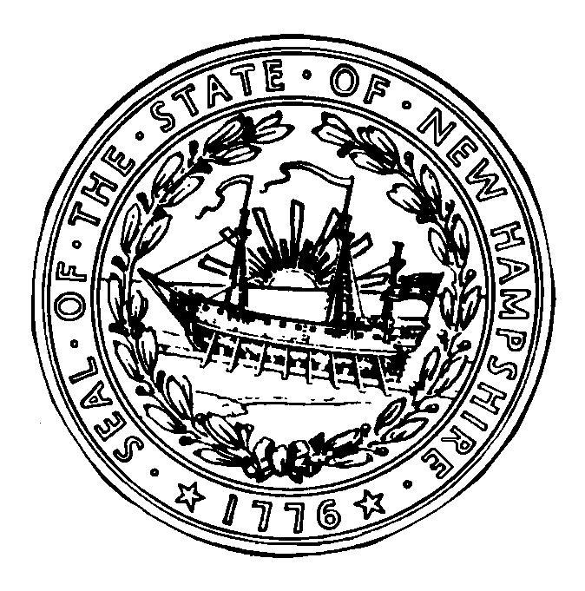

## STATE OF NEW HAMPSHIRE

**DEPARTMENT OF EDUCATION**

**101 Pleasant Street**

**Concord, N.H. 03301**

**TEL 603-271-3495**

**FAX 603-271-1953**

**ATTACHMENT G**

**FOR NON-PROFIT RESIDENTIAL CHILD CARE INSTITUTIONS (RCCI’s)**

**and NON-PUBLIC INSTITUTIONS *ONLY***

***LIST OF BOARD MEMBERS***

As part of the National School Lunch Program Annual Application, please complete the chart below providing the required information concerning ***ALL*** Board of Directors, or individuals in comparable positions, for your Institution or attach a list of your existing Board Members with accompanying information.

The Name of Institution:

|  |  |  |  |  |
| --- | --- | --- | --- | --- |
| **Name of Board Member** | **Title** | **Address** | **Phone** | **email** |
|  |  |  |  |  |
|  |  |  |  |  |
|  |  |  |  |  |
|  |  |  |  |  |
|  |  |  |  |  |
|  |  |  |  |  |
|  |  |  |  |  |

Reviewed 7/2021