**Frank Edleblut**

Commissioner

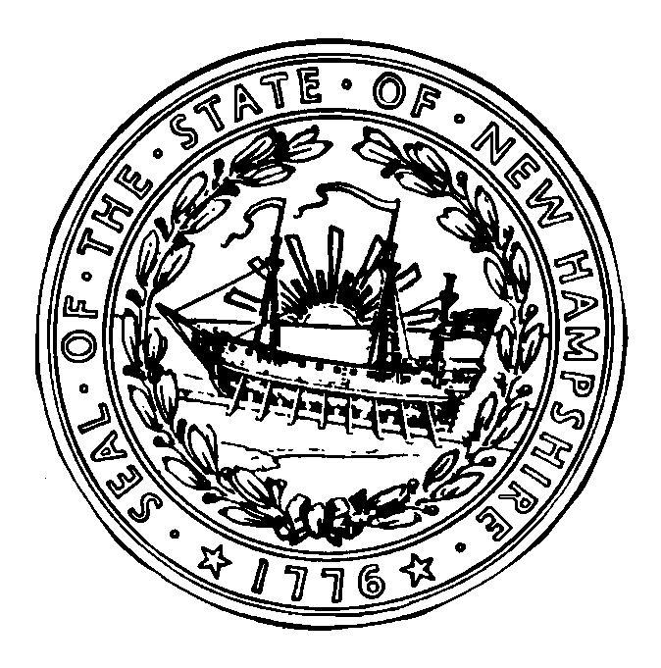

**Christine Brennan**

Deputy Commissioner

## STATE OF NEW HAMPSHIRE

DEPARTMENT OF EDUCATION

101 Pleasant Street

Concord, NH 03301

TEL 271-3495

FAX 603-271-1953

**ATTACHMENT L**

**PROCUREMENT PROCEDURES**

**DECLARATION PAGE**

This is to verify that, the undersigned, have read and understood the Procurement Procedures, as referenced in 2 CFR 200 and outlined as follows, as related to participation in the National School Lunch Program.

For:

SAU # or Name of Residential Institution or Nonprofit Nonpublic School

By:

Signature of Superintendent or Director/Administrator of Institution

Type/Print Name of above

Date Telephone Number

The following documents **must** be uploaded with your 2021-2022 National School Lunch Program

on-line Application:

1. Signed and dated *Procurement Procedures Declaration Page*;
2. The SAU’s Code of Conduct;
3. The SAU’s Procurement Procedures.

*Reviewed 7/2021*

**PROCUREMENT PROCEDURES**

**A. Allowable / Unallowable**

**Procurement Practices**

The purpose of Federal procurement requirements is to provide a system where maximum open and free competition allows a purchaser to acquire the goods and services needed at the best possible price.  It is not the purpose of Federal procurement rules to require child nutrition program operators to purchase sub-standard goods simply because the price is lowest; nor is it the purpose of Federal procurement rules to permit unreliable suppliers access to the child nutrition programs simply because these suppliers underbid reliable companies.

**Allowable Procurement Practices:**

1.    Obtaining publicly available information such as:

* Product brochures, product specification handouts, etc.
* Information obtained from the Internet
* Information/recommendations obtained from other food service personnel
* Information obtained by visiting food service operations, industry and professional trade shows
* Trade journal information

2.    Obtaining information from manufacturers and distributors including:

* Recommendations of one product versus another product
* Features that make one product different from another
* The price for the product
* The price for specific features
* The model number, make, and manufacturer of products that may be acceptable
* Specification sheets and product information hand-outs

**Unallowable Procurement Practices:**

1. Allowing a potential contractor to write the bid or proposal terms, product specifications, and procurement  
 procedures or contract terms.

2. Allowing a potential contractor to evaluate bids or proposals submitted by competitors.

3. Delegating bid/proposal acceptance or recommendation for acceptance to a potential contractor  
 competing on the procurement.

4. Allowing a potential contractor access to sealed bid information before the bids are publicly opened.

5. Disclosing the content of proposal offers submitted by others to a potential supplier prior to the supplier  
 submitting an offer.

6. Negotiating under the formal advertising method (sealed bid) of procurement.

7. Accepting non-responsive bids or offers. 

For additional information on USDA procurement requirements see 7 CFR 210.21; Title 7 Code of Federal Regulations (CFR) 2 CFR 200. These may be found on the Office of Nutrition Programs and Services website at <https://www.education.nh.gov/who-we-are/division-of-learner-support/bureau-of-student-wellness/national-school-lunch-program>.

**B. Buy American**

USDA requires that whenever possible, School Food Authorities shall only purchase food products that are produced in the United States.  Exceptions to the **“Buy American”** requirement are allowed when:  
  
 • The recipients have unusual or ethnic food preferences that can only be met through purchases of  
 products not produced in the United States,

• Products are not produced or manufactured in the United States in sufficient and reasonable available  
 quantities of a satisfactory quality,

• The cost of the domestic produced food products is significantly higher than that of foreign products.

* Documentation of ALL exceptions must be maintained.  
   **C. Debarment and Suspension/Lobbying**

School districts participating in NSLP are prohibited from contracting with a company or individual that has been debarred or suspended in accordance with 2 CFR 200.450.  This prohibition applies to new contracts and extensions or renewals of existing contracts of $100,000 or more and to contracts for audit services, regardless of amount.  A “Certification Regarding Debarment, Suspension, Ineligibility and Voluntary Exclusion” must be filed with all bids of $25,000 or more. See 2 CFR 200.450 for Lobbying Certification for Contracts of $25,000 or more.

**D. Exclusive Beverage and Snack Contracts**

If the Child Nutrition Program is included in exclusive beverage contracts, all federal procurement requirements must be met.  **Copies of the contract and procurement documentation must be available for review**. Federal procurement procedures are found in 7 CFR 210.21 and 2 CFR 200.

These regulations require: "All procurement transactions… without regard to dollar value shall be conducted in a manner that provides maximum open and free competition." Documentation must be maintained to prove that the appropriate procurement procedures were used and that the final selection is the most efficient and economical for the Child Nutrition programs.

There are several other very specific requirements in the regulations based on the method selected to procure products. If a district includes Child Nutrition programs in an exclusive beverage contract, and the district does not have copies of 7 CFR 210.21, or 2 CFR 200, please contact this office.

If the exclusive beverage contract does not include the federal Child Nutrition programs, the contract does not have to comply with the USDA procurement regulations cited above, but it must still comply with the appropriate state procurement requirements.

**E. Procurement Process**

The following are additional excerpts from 7 CFR Part 3016 and 2 CFR 200, which must be followed during the procurement process.

* **Code of Conduct**

2 CFR 200.318 (c) (1) A School Food Authority (local school district) **must maintain** a written standards of conduct governing the performance of their (SFA) employees engaged in the award and administration of the contract. No employee …shall participate in selection or in the award or administration of a contract supported by Federal funds if a conflict or interest, real or apparent would be involved.

2 CFR 200.318 (c) (1) regulations state employees will neither solicit nor accept gratuities, favors, or anything of monetary value from contractors, potential contractors, or parties.

* **Non-geographic Preference**

2 CFR 200.319(b) A School Food Authority (local school district) will conduct procurements in a manner that prohibits the use of statutorily or administratively imposed in-State or local geographical preferences in the evaluation of bids or proposals.

* **Selection Procedures**

2 CFR 200.320 (c) (1) (i) the request for proposal (RFP) or invitation to bid shall incorporate a clear and accurate description of the technical requirements for the material, product, or service to be procured. Such description shall not contain features, which unduly restrict competition.

2 CFR 200.320 (d) (1) the RFP or invitation to bid shall Identify all requirements which offerors (vendors) must fulfill and all other factors to be used in evaluating bids or proposals.

* **Access to Contractor Records**

2 CFR 200.336 (a) access by the grantee (state agency), the Federal grantor agency (USDA), the Comptroller General of the United States, or any of their duly authorized representatives to any books, documents, papers, and records of the contractor which are directly pertinent to that specific contract for the purpose of making audit, examination, excerpts, and transcriptions.

2 CFR 200.333 regulations require retention of all required records for three years after … the final payments and all other pending matters are closed.

CFDA #:

10.555 National School Lunch Program

10.553 School Breakfast Program

10.556 Special Milk Program