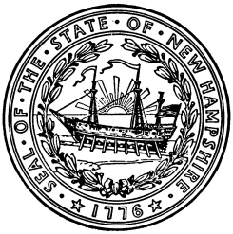

Frank Edelblut Christine Brennan
Commissioner Deputy Commissioner

STATE OF NEW HAMPSHIRE
DEPARTMENT OF EDUCATION
101 Pleasant Street
Concord, N.H. 03301
TEL. (603) 271-3495
FAX (603) 271-1953
ATTACHMENT T1

Non-Program Food Revenue - Reference Period

The State Agency must validate the reference period used for completing the non-program food revenue tool (attachment T) for all School Food Authorities.

The reference period may be a week, a month, or year; however, the reference period must include at least 5 consecutive operating days (or 4 consecutive days for schools operating a 4 day week). The selected days must represent typical food service operations.

Assessments cannot include data from summer school, holidays, or vacations or special circumstances that might distort the program and non-program foods data. For more information, please refer to USDA Policy Memo SP20-2016.

In the chart below, indicate the reference period your SAU/RA used to determine the non-program food revenue tool by placing an X in the appropriate box and indicate the specific time period used associated with the reference period used.

Definition: Nonprogram foods include any nonreimbursable foods and beverages purchased using funds from the nonprofit school food service account. This encompasses all foods sold in schools as well as adult meals, foods sold outside of school hours or any foods used for catering or vending activities. For the majority of SFAs, a la carte foods offered during meal service account for the largest share of nonprogram foods. Reference: https://www.fns.usda.gov/cn/nonprofit-school-food-service-account-nonprogram-food-revenue-requirements

SAU/RA #: _______________

Reference Period  (Please select one) | Indicate the specific time period  (Example: Week = March 9 – 13, 2021)
Week
Month
Year

Reports used to complete the Non-Program Food Revenue Tool for the selected reference period are included in this attachment.

“This institution is an equal opportunity provider.”

