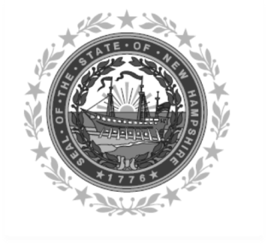

Frank Edelblut Christine M. Brennan
Commissioner Deputy Commissioner

STATE OF NEW HAMPSHIRE
DEPARTMENT OF EDUCATION
25 Hall Street
Concord, NH 03301
TEL. (603) 271-3495
FAX (603) 271-1953

TO: Child and Adult Care Food Sponsors

FROM: Patty Carignan, Program Specialist IV

RE: Categorical Eligibility

USDA federal regulation 226.6(f)(10), requires the State Agency to provide all sponsoring organizations of day care homes with a list of categorically eligible State funded programs.

- Participation in the listed programs by a parent or a child will qualify a meal served to a child in a Tier II home for the Tier I rate of reimbursement.

- Participation in the TANF (Family Assistance Program and NH Employment Program) and USDA SNAP Programs qualify an applicant for the Tier I rate of reimbursement.

Listed below are the categorical programs that may be used to determine categorical eligibility.

- TANF participation and USDA SNAP Programs administered by the NH Health and Human Services Department
- NH Fuel Assistance Program administered by the Governor’s Office of Energy and Planning
- USDA Commodity Supplemental Food Program administered by the NH Health and Human Services Department
- USDA National School Lunch and Breakfast Program administered by the NH Department of Education

The Federal regulations apply only to Family Day Care Home children in a Tier II home.

Please refer to the Eligibility Handbook for more detailed requirements for eligibility determinations or contact your State Agency Child and Adult Care Food Program Specialist, Patty Carignan @
(603) 271-3862 or email patricia.carignan@doe.nh.gov

USDA Nondiscrimination Statement:

In accordance with federal civil rights law and U.S. Department of Agriculture (USDA) civil rights regulations and policies, this institution is prohibited from discriminating on the basis of race, color, national origin, sex (including gender identity and sexual orientation), disability, age, or reprisal or retaliation for prior civil rights activity.
Program information may be made available in languages other than English. Persons with disabilities who require alternative means of communication to obtain program information (e.g., Braille, large print, audiotape, American Sign Language), should contact the responsible state or local agency that administers the program or USDA’s TARGET Center at (202) 720-2600 (voice and TTY) or contact USDA through the Federal Relay Service at (800) 877-8339.
To file a program discrimination complaint, a Complainant should complete a Form AD-3027, USDA Program Discrimination Complaint Form which can be obtained online at: https://www.usda.gov/sites/default/files/documents/ad-3027.pdf, from any USDA office, by calling (866) 632-9992, or by writing a letter addressed to USDA. The letter must contain the complainant’s name, address, telephone number, and a written description of the alleged discriminatory action in sufficient detail to inform the Assistant Secretary for Civil Rights (ASCR) about the nature and date of an alleged civil rights violation. The completed AD-3027 form or letter must be submitted to USDA by:
- mail:
U.S. Department of Agriculture
Office of the Assistant Secretary for Civil Rights
1400 Independence Avenue, SW
Washington, D.C. 20250-9410; or
- fax:
(833) 256-1665 or (202) 690-7442; or
- email:
Program.Intake@usda.gov

This institution is an equal opportunity provider.

