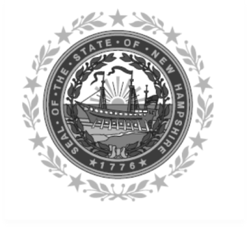

Frank Edelblut Christine M. Brennan
Commissioner Deputy Commissioner

STATE OF NEW HAMPSHIRE
DEPARTMENT OF EDUCATION
101 Pleasant Street
Concord, NH 03301
TEL. (603) 271-3495
FAX (603) 271-1953

Fresh Fruit and Vegetable Program (FFVP)
“Certification of Support”

(Must be completed by each school identified on the “Letter of Intent”

participating in the FFVP in your SAU).

SAU #: _______ School Name:_________________________________________________________

We have reviewed and updated the on-line SAU and site applications and attest to the information provided. We agree to implement the program in a manner consistent with the policies, procedures and regulations established by USDA. Further, we agree to participate in any USDA-sponsored evaluations and to provide the information requested by the specified deadlines.

SCHOOL PRINCIPAL
*Signature of School Principal | (Please print name)
Date Signed

SCHOOL FOOD SERVICE DIRECTOR
*Signature of School Food Service Director | (Please print name)
Date Signed

SCHOOL FOOD SERVICE MANAGER
*Signature Food Service Manager Signature | (Please print name)
Date Signed
*Signature required.

