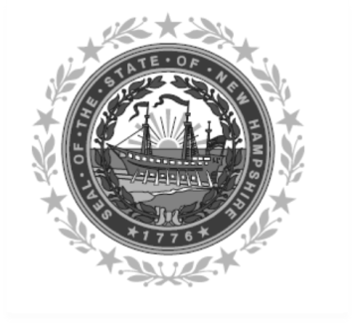

Frank Edelblut Christine M. Brennan
Commissioner Deputy Commissioner

STATE OF NEW HAMPSHIRE
DEPARTMENT OF EDUCATION
101 Pleasant Street
Concord, NH 03301
TEL. (603) 271-3495
FAX (603) 271-1953

TO: Fresh Fruit and Vegetable Program (FFVP) Participants
FROM: Cheri F. White, Administrator, Bureau of Nutrition Programs and Services
RE: Letter of Intent - FFVP School Year 2020-2021
DATE: August 2020

This is to inform you that the Department of Education, Office of Nutrition Programs and Services will once again be offering qualifying schools the opportunity to participate in the USDA Fresh Fruit and Vegetable Program for School Year 2020-2021. The FFVP will run from October 2020 through September 2021.

This form MUST be completed and uploaded with your annual SAU FFVP on-line application. Failure to upload this form with your on-line application may result in your SAU not being able to participate in the FFVP for this school year.

YES, the SAU is interested in participating in the FFVP for the schools listed below for School Year 2020-2021.
- NO, the SAU is NOT interested in participating in the FFVP for School Year 2020-2021.

SAU Number: ___________

Schools Wanting to Participate in the FFVP
(Refer to the 2020-2021 NH FFVP List of Qualifying Schools and write the name of the school(s) in your SAU that would like to participate in the FFVP in the chart below.) Use additional sheets if needed.
School Name | School Name
Name of Primary FFVP Contact Person for FFVP
Phone # of Primary FFVP Contact Person
E-mail of Primary FFVP Contact Person

Signature of Superintendent of Schools Date Signed

