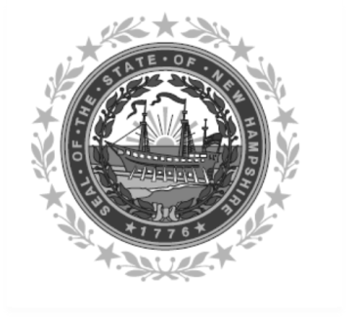

Frank Edelblut Christine M. Brennan
Commissioner Deputy Commissioner

STATE OF NEW HAMPSHIRE
DEPARTMENT OF EDUCATION
101 Pleasant Street
Concord, NH 03301
TEL. (603) 271-3495
FAX (603) 271-1953

INCOME ELIGIBILITY GUIDELINES

(Effective from July 1, 2023 to June 30, 2024)

FREE MEAL GUIDELINES (130%)

HOUSEHOLD SIZE | INCOME (Equal to or Less Than)
 | YEARLY | MONTHLY | WEEKLY | Twice Per Month | Every Two Weeks
1 | $18,954 | 1,580 | 365 | $790 | $729
2 | 25,636 | 2,137 | 493 | 1,069 | 986
3 | 32,318 | 2,694 | 622 | 1,347 | 1,243
4 | 39,000 | 3,250 | 750 | 1,625 | 1,500
5 | 45,682 | 3,807 | 879 | 1,904 | 1,757
6 | 52,364 | 4,364 | 1,007 | 2,182 | 2,014
7 | 59,046 | 4,921 | 1,136 | 2,461 | 2,271
8 | 65,728 | 5,478 | 1,264 | 2,739 | 2,528
For each additional  Household member add | + $ 6,682 | + $ 557 | + $ 129 | + $ 279 | + $ 257

REDUCED PRICE MEAL GUIDELINES (185%)

HOUSEHOLD SIZE | INCOME (Equal to or Less Than)
 | YEARLY | MONTHLY | WEEKLY | Twice Per Month | Every Two Weeks
1 | $ 26,973 | 2,248 | 519 | 1,124 | 1,038
2 | 36,482 | 3,041 | 702 | 1,521 | 1,404
3 | 45,991 | 3,833 | 885 | 1,917 | 1,769
4 | 55,500 | 4,625 | 1,068 | 2,313 | 2,135
5 | 65,009 | 5,418 | 1,251 | 2,709 | 2,501
6 | 74,518 | 6,210 | 1,434 | 3,105 | 2,867
7 | 84,027 | 7,003 | 1,616 | 3,502 | 3,232
8 | 93,536 | 7,795 | 1,799 | 3,898 | 3,598
For each additional  Household member add | + $ 9,509 | + $793 | + $ 183 | + $ 397 | + $ 366
Note:
The press release should contain both the Free and Reduced Price scale.
The letter to the parents for meal programs must only contain the Reduced Price scale.
The letter to the parents for the Special Milk Program must only contain the Free price scale. 2023-2024

