Maintenance of Equity Tracking – Q&A
Webinar Hosted by Allison Seils, Division of Learner Support
NH Department of Education
September 23, 2021

- Can you please explain why a District was identified as required to comply with MOEq? I am looking at the two highest schools in my District and the percentages are 25% and 17%. Much lower than your sample. Just need greater context on the "why?"
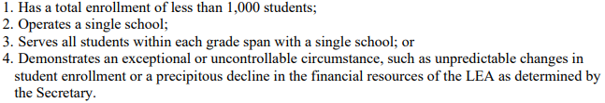
  - Each of the 163 districts comprising the State were analyzed based off of FY2020 and FY2021 enrollments and free and reduced lunch program counts year-over-year. Districts that met one of the following criteria were non-exempt from completing MOEq tracking requirements:

  - Of the 163 districts analyzed, just over 30 remained non-exempted from maintaining equity for fiscal years 2022 and 2023. Regardless of poverty, percentage recorded across each school within each district— if the District was deemed non-exempted from the MOEq requirements above—it was selected per MOEq requirement in maintaining provisional compliance.
  - Note: We cannot measure exemption in regards to criterion #4 just yet, as we do not yet have the details available, by District, in whether a District may be exempted due to a potential exceptional/uncontrollable circumstance (more to come!).

- For single school districts, this is not required, correct?
  - That is correct; a District that serves a single school will not be required to comply with MOEq requirements for fiscal year 2022.

- Are there implications on how we spend the funds per school?
  - For the purposes of today’s webinar in covering the first part of tracking requirements measured in sufficing the MOEq compliance provision, we are not measuring funding use. However, non-compliance with the MOEq could potentially result in Secretary Cardona taking action against a district. This punitive action may involve ESSER III funding, but we do not have any further information to provide at this time.
  - We will be working with districts following receipt of all requested high-poverty classification materials on October 5th, where we will be presenting more information

- Question on funding. We are planning to spend 80% at one school (our Middle School). How does that affect MOEq if we choose our two elementary schools as High Poverty?
  - There is not a supplement or supplant requirement drawn into ESSER III (ARP Act).
  - If your District is planning to spend 80% towards its middle school, it may still designate its two elementary schools as high poverty assuming that in doing so, the District does not reduce the following for its two elementary schools designated as high poverty:
    - Per pupil spending of state and local funds, or
    - FTE’s for any high poverty school by an amount that exceeds the total reduction(s) within the District
  - Please reference the following resource for more information (see A-18): U.S. DOE - ESSER & GEER Q&A's Released May 26, 2021

- The slide at the beginning of your presentation indicated that the base year was FY 20, which for us is 2019-2020. However, later on slide 8 you indicate that the base year is 2020-2021. Which is correct?
  - The base year for measuring FY 22 compliance is FY 2021. However, we are using school year 2019-2020 pupil data for our FY 2021 base year measurements. This is because adequacy funding is one year behind and USED allowed enrollment data to align with State funding formulas.

- Is there a minimum percentage of poverty for exemption? If average is less than 5% for example.
  - No, to our knowledge as of this time, there is no minimum percentage of poverty for exemption.

- If we have two schools with no overlap, are we required to comply with MOEq requirements for FY22?
  - If a District has any overlap recorded by grade span, it will be non-exempted from complying with MOEq requirements as outlined per criterion #3 in measuring MOEq exemption.

- Can you tell us what you are doing with this information as far as how the ESSER grant is funded?
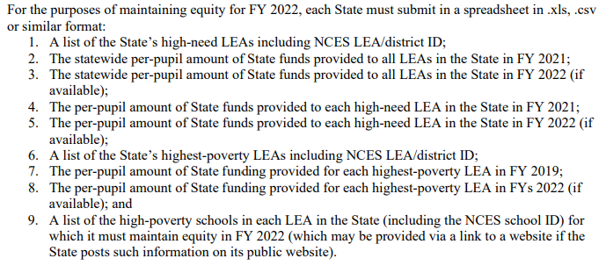
  - Each State in receipt of ARP ESSER funds must track MOEq compliance for fiscal years 2022 and 2023. States are required to collect the following information from its districts on behalf of each fiscal year:
  - In providing the information recently requested from each qualifying District, districts will be sufficing requirement #9 above, which will allow for the State of NH to further analyze requirements 1 to 8 as referenced via our webinar as an [separate] upcoming deliverable following each District’s high poverty classification (October 5th).

- What are the Districts tracking? Do more dollars have to be allocated to the higher poverty schools?
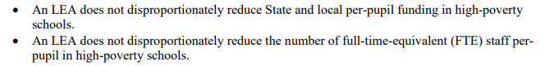
  - Districts in receipt of ARP ESSER funding are measuring their ability to comply with the following MOEq requirements for FY22 and FY23:

  - In order to track a District’s compliance in maintaining tracking measures across fiscal year, we must first allow each District to identify what school(s) will be classified as high poverty, beginning with FY22.

  - More funding does not necessarily have to be allocated to higher poverty schools for FY22 and FY23; however, districts must not:
    - Reduce combined State and local per-pupil funding for any high-poverty school by an amount that exceeds the total reduction, if any, of combined State and local per-pupil funding for all schools in the LEA, and
    - Reduce the number of FTE staff per-pupil in any high-poverty school by an amount that exceeds the total reduction, if any, of FTE staff per-pupil in all schools in the LEA
  - We will be exploring the methodology behind tracking each District’s equity and how it is we will be accomplishing this measure following receipt of each District’s high poverty classification designation (October 5th – more to come).

- If you are tracking compliance … what are you tracking?
  - See answer to Question #9 above. We are tracking each District’s ability to maintain equity requirements as mandated by the U.S. Department of Education for fiscal years 2022 and 2023. See more here: MOEq Frequently Asked Questions - U.S. Department of Education.

- If we have one school that is K-5 and one school that is 6-12, are we exempt?
  - Assuming you have no other schools within your District that have grade spans that overlap one another, yes, your District would be exempted from MOEq requirements for FY22.

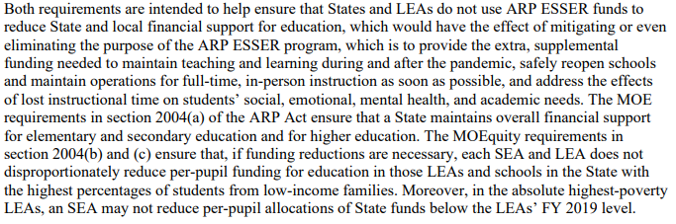
- Under the Special Education Maintenance of Effort we can provide explanations of why there are reasons for reductions. Will that be provided under this method?
  - To clarify, Maintenance of Effort is a completely separate provision from what we are covering today (Maintenance of Equity):
  - For now, explanations related to potential exception are not needed. As we work through the data collection requested and are within a position to analyze FY22 budgetary data, we will be within a better position to further determine whether a potential request for MOEq exception may be advantageous for your District.

- If I select Option #1, I would simply select the "yes" drop downs for the two schools. Is that it? Or do I need to select the "No" drop downs in Option 2 and 3.
  - Please either identify “Yes” or “No” for each school outlined within your District to confirm agreement or disagreement with the pre-selections applied.

